

.

# SMART ELECTRONIC SYSTEM FOR DANCING FOUNTAINS CONTROL CAPABLE TO CREATE WATER AND LIGHTING SCENARIOS

SYNCHRONIZED WITH A MUSIC TRACK

# PHASE 4 NAME : PALIMKOTA YASWANTH

NMID : au723921106011

# EMAIL : [palimkotayaswanth@gmail.com](mailto:palimkotayaswanth@gmail.com)

### ABSTRACT

This work regards on hardware and firmware development of an electronic control and driving system for dancing fountains, able to manage water and lighting scenarios synchronized with mp3 music files stored on an external SD memory card connected to the designed system. The smart PIC-based control unit reproduces the music file related to a particular scenario and drives, in a synchronized way, fountain’s LED-based headlights and water pumps to create amazing light and water plays.

**Keywords:** microcontroller; control and driving system; dancing fountains; light and water plays, hardware and software development.

structure of a dancing fountain: it drives water pumps and

### INTRODUCTION

In last years, people’s needs in the fields of aesthetic taste, comfort and attention to details have considerably changed. In outdoor furniture field, more and more people requires particular features to make their spaces cozy, liveable and original. This trend has also affected a classical element of outdoor furnishings: the fountains. The simple gush of a fountain now is not enough, people wants and tries a greater visual impact. In order to meet this demand, specialized designers have created the dancing fountains (or musical fountains), which combine water and light plays on the basis of a reproduced music track. This new type of furniture has collected considerable success in recent years, creating a new and highly demanded field in the fountains' market. Two famous examples of dancing fountains already installed in our cities are reported in Figure-1: on the left the one of Placa d'Espana, Barcelona and on the right the one of Bellagio's casino, Las Vegas.



**Figure-1.** Dancing fountains in Plaça d’Espanya, Barcelona (on the left) and near Bellagio casinò, Las Vegas (on the right).

In this work, it was designed and implemented an electronic control system able to manage the entire

LED-based lights, reproduces the music files and synchronizes water and light scenarios with the music itself. This system is equipped with an mp3 reader for music reproduction and with a slot for SD memory, on which the system stores mp3 music files and the related scenarios. In this way, the user can create custom scenarios on the basis of the own fountain, through a dedicated software supplied with the control system. The architecture of a typical dancing fountain managed by the designed control system is reported in Figure-2: the controller drives, through dedicated power drivers, the water pumps and LED-based headlights in order to realize scenarios with amazing water and light plays, and at the same time it plays the music through the sound system.

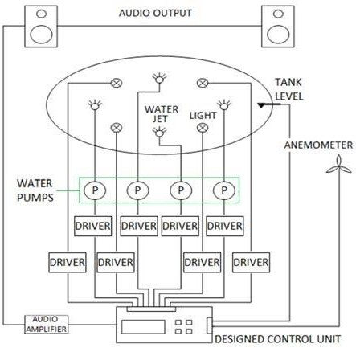



**Figure-2.** Block diagram of the general structure of a dancing fountain managed by the designed control and driving system.

has been implemented a PC software with which the user can create a digital file related to a particular water and light’s scenario. Each byte of the binary file created through this software represents the state of the eight digital outputs at every moment, as reported in the block diagram of Figure2, used to drive the water pumps and LED-based headlights. Each file is related to a particular scenario and is associated to a specific (.mp3 or .wav) music file. All scenario and musi.

### Architecture of the designed control system

The Figure-3 shows an architecture scheme of the developed control system for musical fountains.

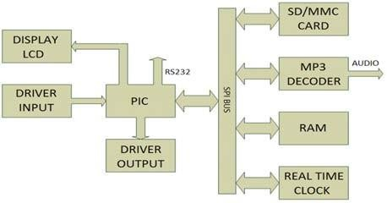

**Figure-3.** Architecture scheme of the designed control system.

As can be observed in the figure above, the designed system is composed by the following units: ▪ an interface for the access to SD memory card;

* a decoder for the reproduction of the music files;
* a real-time clock for setting of scenario’s start time;
* an interface for auxiliary inputs;
* a keypad and a LCD display for user interfacing;
* an RS232 serial interface for system’s local monitoring;
* an interface for control and driving of the outputs;
* a microcontroller for system’s management and a RAM memory module.

After system boot, the first step is to set the start data and time of the desired scenario. When the real-time clock (RTC) reports to microcontroller this start time, this last accesses SD memory (formatted with FAT32 file system), finds the file related to the programmed scenario and copies it into the RAM module. Thereafter, the microcontroller accesses again the SD memory, finds the music file associated with the scenario and sends its content to mp3 decoder. The decoder, which was set in listening state from the initial reset, starts the data stream's decoding and the music reproduction. At the same time, PIC's firmware

reads, from RAM module, the scenario file and, on the basis of this one, updates the system's outputs related towater pumps and headlights control, obviously synchronizing this operation with the reproduced music.

The first step in the design and realization of this control system was the choice of mp3 decoder. It has been selected the VS1011e integrated circuit of VLSI Solution, because of its technical features suitable for the specific application. It is provided with an mp3/wav decoder with a reliable digital signal processing (DSP) chip, that exhibits high performances and low power consumption, combined to a 18-bit digital-analog converter (DAC) and to an audio amplifier for earphone. The VS1011e embedded chip, with Slave role, receives as input a bit stream through the Serial Peripheral Interface (SPI) bus, decodes it and sends the result to the 18-bit sigma-delta DAC.

The entire PIC-interfacing and decoding process is controlled by the Serial Control Interface (SCI) module, used for reading/writing of control registers that select the functioning mode, set the clock, choose the visual effects, set the volume and so on. It's also possible to set custom specifications and to save them into a user section of the RAM memory of 0.5kB capacity. The Figure-4 shows the internal architecture of the VS1011 mp3 decoder.

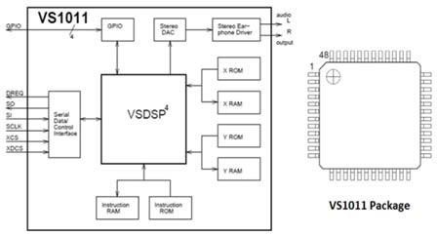

**Figure-4.** Block diagram of the internal hardware architecture of VS1011e decoder (on the left) and LQFP external package of the used mp3 decoder (on the right).

For the storage of scenario and music files, it has been used a Secure Digital memory, connected to microcontroller through the SPI interface. The microcontroller chosen for the designed control system is the PIC18F822 of Microchip's PIC18 family. The only features researched in the PIC device’s choosing were the presence of SPI interface for mp3 decoder and SD memory management, of a serial interface for PC connection and of a high number of inputs and outputs pins for the control of the components shown in Figure-2. The designed control system extracts the scenario file from SD memory and stores it into an external RAM memory (shown in Figure- 5) in order to allow its easier and faster management and thus a better synchronization with the music file.

5669

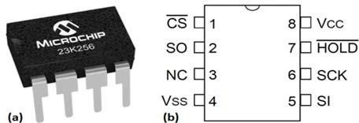

**Figure-5.** Microchip 23K256 RAM memory chip (a) and related packaging scheme with the description of the pins’ functions (b).



The chosen RAM module is the Microchip 23K256 IC, which has the following technical features: ▪

SPI access interface;

* [2.7 ÷3.6]V range for power supply voltage, suitable also for the other components and devices of the realized controller; ▪ static memory: no refreshing needs; ▪ 256 KBcapacity.

The chosen memory capacity is more than enough, since for a single scenario with a music file of 5 minutes duration; about 24 KB of memory are needed. In order to establish start data and time of a programmed scenario, the control system uses the ST Microelectronics M41T93 RTC device. The designed system controls the drivers for the water pumps and the LED-based headlights. These drivers represent the power section of the overall system; therefore they must be insulated from the smart PIC-based processing section. For this purpose, it was realized an intermediary driver which adapts the voltage levels and, at the same time, insulates the power section from the control section of the board, through the TPL-627 opto-couplers with a Darlington BJT transistor as a sensing element. The circuital scheme, shown in Figure-6, is composed by the TPL-627 opto-couplers driven by PIC's digital outputs for water pumps and headlights control and by the power lines (J6 output connector) for the managing of power drivers.

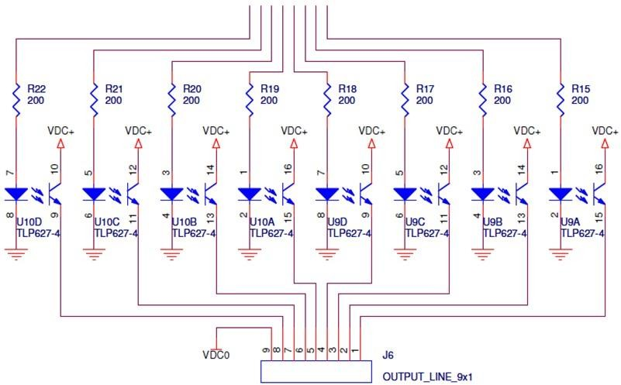

**PIC’soutputs**

**Figure-6.** Circuit for voltage level adaptation and for insulation of the power section from the control section of designed board.

The designed system is provided with a numeric keypad for user interfacing and with some analog inputs for the anemometers and for a fluid level sensor, used for detecting the water level in the fountain's pool. These sensors are useful for adjusting the power of the water jets according to the wind's force and water level in the pool. Also the input lines must be opto-coupled, since the used transducers require voltage levels greater than board's power supply voltage (3.3V). The adopted and realized circuital solution in shown in the Figure-7.

## 5670



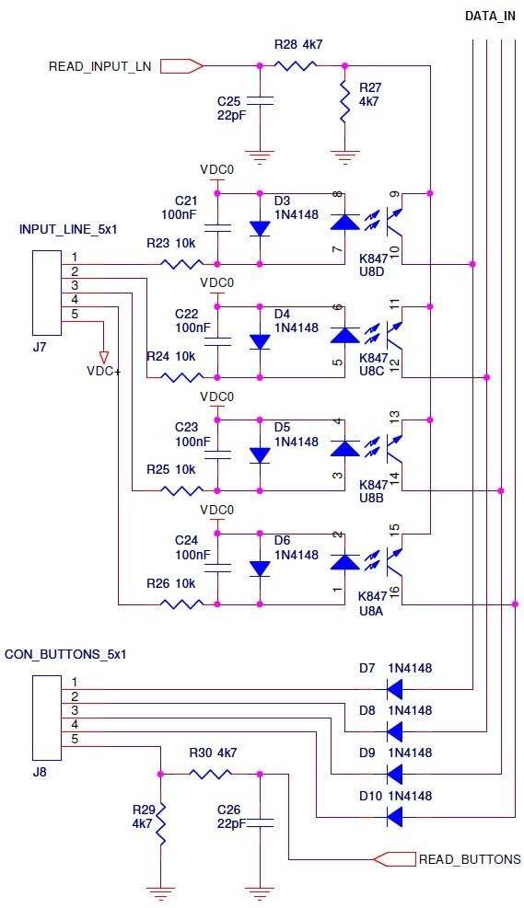

**Figure-7.** Realized circuit to get electrical isolation of input lines connected to the transducers used in the designed control system.

As shown in the Figure-7, the input lines provided by the*INPUT_LINE*_5x1 connector, coming from the water level and wind force sensors, pass through a debounce circuit in order to attenuate the abrupt signal variations caused by some oscillatory phenomena on the transducers. The debounce circuit is composed by a 10kΩ resistor, a 100nF capacitor and a protection diode for eventual inverse currents. The input lines connected to the sensors and to keypad (*CON_BUTTONS*_5x1 connector) converge on the same input data bus (*DATA_IN*). The needed multiplexing operation between the *INPUT_LINE* and *CON_BUTTONS* input lines is performed through the *READ-INPUT_LN* and *READ_BUTTONS* selection bits and by means ofthe four diodes (D7-D10) present, on the circuit, right after the keypad. Both selection lines have an anti-spike circuit (a 4,7kΩ resistor in series and a 22pF capacitor) and a further 4,7kΩ resistor to avoid current overload on output pins of the microcontroller.

In the architecture of the designed control system, the graphical user interface is composed by a 16x2 LCD display that shows the control messages. For system's power supply, a specific circuital section has been designed, with the necessary surge protection (caused from the power loads connection). The power supply section provides two different and stabilized voltage levels, the

first equal to 3.3V for the PIC, SD memory, mp3 decoder, RAM module, RTC, LCD and keypad while the second one equal to 12V for input and output drivers.

The designed and realized circuital solution is shown in the Figure-8.

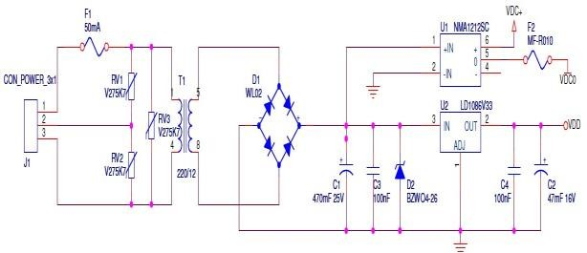

**Figure-8.** Circuital scheme of the surge protection and power supply sections (with ac/DC adapter and suitable DC/DC converters) in order to generate stabilized

3.3/12V voltage values.

In order to satisfy the surge protection needs, some varistors have been used on 50Hz (VRMS=230V) main voltage side (on the left of T1 transformer with N1/N2 = 220/12) and a Zener diode D2 with voltage breaker role on the DC voltage side (after T1 transformer and the diode bridge). The 3.3V stabilized voltage is generated by the LD1086V33 voltage regulator, which provides a maximum current of 1.5A and is contained in a TO220 package in order to allow the mating with a heat sink. The 12V insulated voltage is guaranteed by the NMA1212SC DC- DC converter (manufactured by *Murata Power Solutions*), which receives as input a 12V DC voltage and provides at its output a ±12V DC voltage with the added benefit of galvanic isolation to reduce the switching noise.

The Murata Power Solutions NMA series of DC/DC converters, in effect, guarantee a 1kV DC insulation (for 1 second) between the input and output circuits. In the circuital scheme of Figure-8, VDC+ represents the +12V DC insulated voltage generated by the NMA1212SC DC-DC converter, VDC0 represents the insulated ground for the driver units and VDD indicates the 3.3V DC stabilized voltage generated by the 12V/3.3V DC LD1086V33 voltage regulator.

### Hardware realization of prototype of the designed control and driving system

After the circuit designing and software simulation phases, a prototype of the control/driving system has been realized in order to test its functionalities. For PIC18F8722 programming and following test and debugging of the developed firmware, the Microchip

## 5671

PICDEM HPC Explorer Board, shown in Figure-9, has been used.



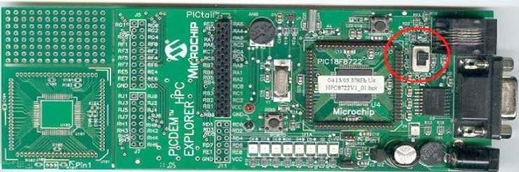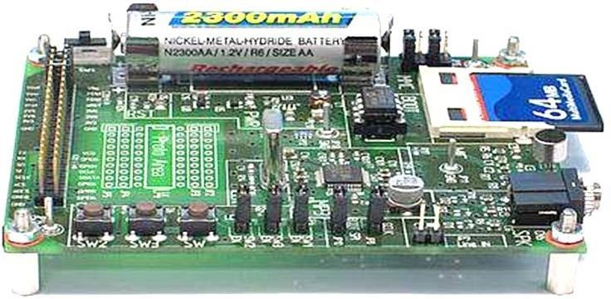

**Figure-9.** Microchip PICDEM HPC Explorer Board formicro controller’s programming and debug.

In order to test SD memory access, it has been used the PIC-tail Daughter Board for SD and MMC cards, shown in Figure-10. This electronic board is an expansion module for the PICDEM HPC board, which, in this way, has the mother-board role and allows the interfacing between the SD or MMC memory unit and the microcontroller's SPI bus. The expansion module is vertically connected to the PICDEM HPC development board through a pin connector composed by 2 lines each of 14 pins.

**Figure-10.** PIC-tail Daughter Board expansion module for SD or MMC memory connection to PICDEM HPC

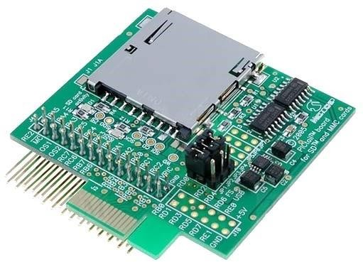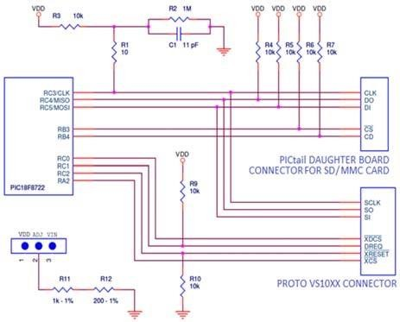

development board.

On the expansion module, between the connector and pins of SD memory, there are some buffers for adapting the [0-5] V DC voltage levels of the signals generated by microcontroller to [0-3.3] V DC voltage levels required for the SD memory. The power supply voltage (3.3V) is provided by a voltage regulator which receives as input the voltage from PICDEM HPC board and reduces it at the proper 3.3V value. Two LEDs are used to indicate the proper power supply and operations of the SD memory.

In the designed control system, the music files stored on SD memory are reproduced during the scenarios execution by means of an mp3 reader. For this reason, the VS10xx proto-board (shown in Figure-11) is used for connecting VS1011e mp3 decoder to the realized system prototype.

## 5672

**Figure-11.** VS10xx Proto Board forthe connection of VLSI Solution VS1011emp3 decoder to the realized

system prototype.

The VS10xx proto-board is a simple stand-alone mp3/wav reader and constitutes an easy platform for all VLSI Solution's products. It has embedded the slot for a common 1.5V AA battery, the VS1011e mp3 decoder integrated into the LQFP package, a 12.288 MHz quartz, an EEPROM memory for firmware loading, three buttons, an SD connector (only for stand-alone uses), appropriate interface circuits for earphone audio output and for the microphone input, a boost circuit for rising the 1.5V power supply voltage and a series of jumpers and connectors for custom circuit configurations. Thanks to these connectors, the VS10xx proto-board has been connected to Microchip PICDEM HPC board and then to the microcontroller. In this case too, the [0-5] V DC microcontroller's voltage levels have been adapted to [0 - 3.3] V DC voltage levels required by the mp3 decoder, reducing mother-board power supply through a voltage regulator. On Microchip mother- board, there is a connector with three pins, each connected to a pin of the voltage regulator.

As reported on PICDEM HPC guide, in order to set voltage to the desired value, a 1.18kΩ resistor with 1% tolerance must be connected between the 2nd pin (the central one) and ground. Resistors with these features don't exist on the market, therefore a resistance of 1.2kΩ (near to desired value) has been generated through a 1kΩ and a 200Ω resistors connected in series. Thanks to this

**Figure-13.** Hardware prototype of the designed control system, assembled in its full version through the

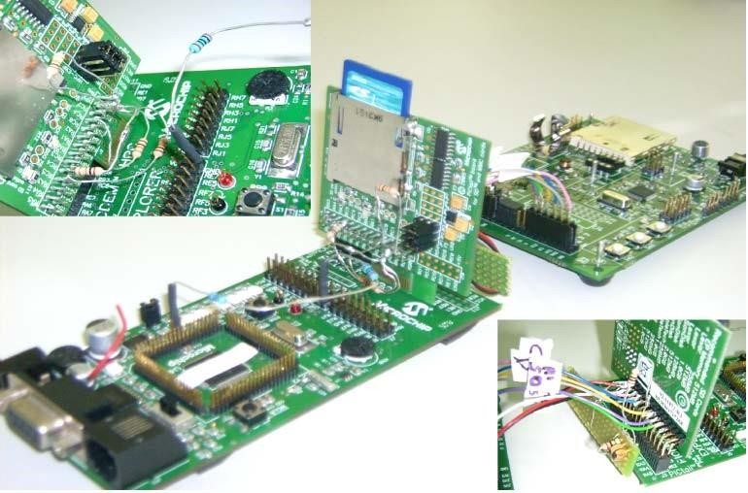interfacing of different development boards in order to test its proper functioning.

### Firmware development for managing of scenarios consisting of water and light plays

The PIC18F8722 microcontroller is driven by a firmware composed of five files, written in C language by means of C18 compiler of MPLAB development platform. The implemented functions present an high abstraction level: the microcontroller's main operations can be understood by code reading, but the low level operations remain hidden on both hardware and software points of view. The flow chart in Figure-14 shows the different working modes and the sequence of executed instructions



[www.arpnjournals.com](http://www.arpnjournals.com/)

resistance, 5V VDD voltage has been regulated to 3.3V DC value. The proper operation of PICDEM HPC + PICtailboards system has been verified and then the VS10xx proto-board has been connected in order to complete the experimental setup. In Figure-12 the circuital scheme of the realized prototype is shown.

**Figure-12.** Circuital scheme of the realized prototype of designed control/driving system.

In Figure-13 is reported a complete image of realized prototype of the control system, which shows the interfacing of each hardware module described during this paragraph: in the magnified image on top left, the pull-up resistors and VDD regulation resistors can be seen, while on bottom right corner, the impedance matching of the SCK line is shown.

from the processing unit of the control system; therefore it can support the reader in the firmware comprehension.

## 5673

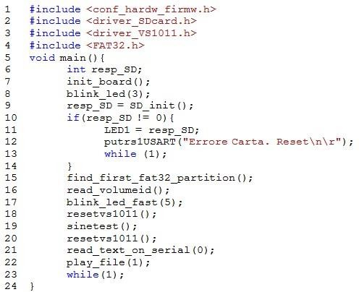

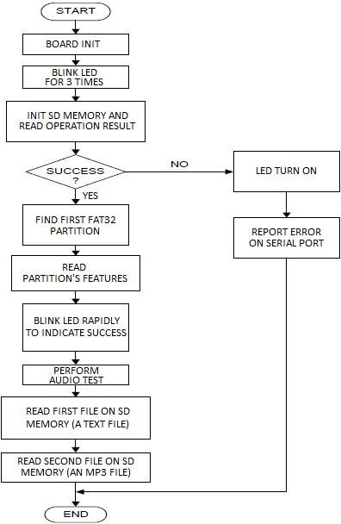**Figure 14.** Architecture of the firmware developed for the designed control/driving system of the dancing fountains.

Substantially, the written code is divided into five

files:

* main.c
* conf_hardw_firmw.h
* driver_SDcard.h
* FAT32.h
* driver_VS1011.h

The *main.c* file, shown in the screenshot of Figure-15, contains the main of the project which includes all other project files.

**Figure-15.** Screenshot of *main.c* file of the developed firmware.

The other project files are included in the first four code lines of *main.c*. Starting from the fifth line, the code follows the structure shown in the flow chart. First of all, the firmware resets the mp3 decoder. Thereafter, a sound test is performed (*sinetest()* function), the first file on the SD memory, a text file, is read and sent on the serial port (*read_text_on_serial(0)*funtion) and after the second file on SD memory, an mp3 file, is reproduced (*play_file(1)* function). All PIC configurations and the board's base functions are enclosed in the *conf_hardw_softw.h* file. The physical communication between the microcontroller and SD card is implemented in the *driver_SDcard.h* file. The FAT2 library is a driver for the FAT32 file system and it has been implemented in order to access to the data blocks in the memory and find, into the file system, all sections of a certain file. The code that allows the communication with the mp3 decoder is contained in *driver_VS1011.h file*. It makes possible the creation and sending of a command to the VS1011e device, the hardware or complete device's reset, the audio test execution and finally the sending of a data block to the mp3 decoder. The end of a mp3 file is indicated through a stream of 2048 zeros.

For PIC programming and debug, it has been used the Microchip MPLAB ICD2 PIC programmer and the MPLAB IDE software. This programmer was connected to the Microchip PICDEM HPC board, as shown in Figure- 16a, through the RJ25 6-pins connector schematically detailed in Figure-16b.

Finally, by performed tests relative to the music files' reproduction, it can be stated that the developed firmware ensures an high audio reproduction quality of the mp3 music files.

## 5674



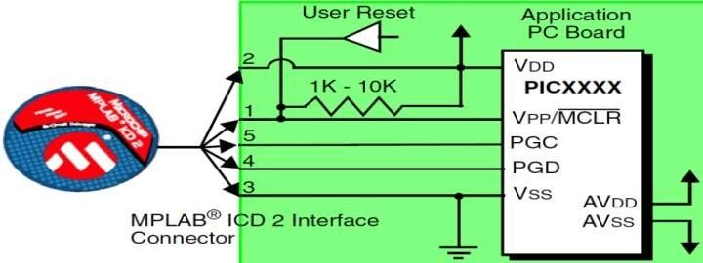

(a)

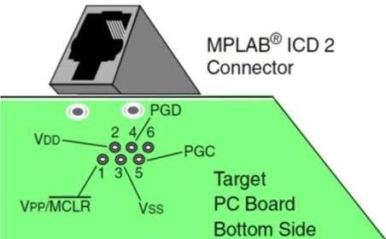

(b)

**Figure-16.** Connection between the MPLAB ICD2 programmer and the realized prototype of the

control/driving system (a) and a detailed scheme of the used RJ25 (6 pins) connector.

### CONCLUSIONS

In conclusion, the realized control/driving system, by means of the smart programmable PIC as processing and control unit, through the connection to the external RAM memory, is able to manage the access and reading of the files, previously stored in the SD memory card, related to a programmed music and water/light scenario. The innovation of this system consists in the realized synchronization between the music track and the water/lighting plays. Future steps will regard the PCB realization in SMT technology and the subsequent testing of the control/driving system applied to a real dancing fountain.

### REFERENCES

1. P.Visconti, R. Ria, G. Cavalera. 2015. Development of smart PIC-based electronic equipment for managing

and monitoring energy production of photovoltaic plan with wireless transmission unit. Journal of Engineering and Applied Sciences ARPN. 10(20): 9434-9441.

1. P. Visconti, P.Costantini, C.Orlando, A. LayEkuakille,

G. Cavalera. 2015. Software solution implemented on hardware system to manage and drive multiple bi-axial solar trackers by PC in photovoltaic solar plants. Measurement - Elsevier. 76: 80-92, DOI: 10.1016/j.measurement.2015.08.024.

1. P. Visconti, P. Costantini, G. Cavalera. 2015. Design of electronic programmable board with user-friendly touch screen interface for management and control of thermosolar plant parameters. IEEE Conf. Proc. of EEEIC 2015 Int. Conference on Environment and Electrical Engineering. pp. 284-289-DOI: 10.1109/EEEIC.2015.7165553.
2. P. Visconti, G. Cavalera. 2015. Intelligent System for Monitoring and Control of Photovoltaic Plants and for Optimization of Solar Energy Production. IEEE Conf. Proc. of EEEIC Int. Conf. on Environment and Electrical Engineering, pp. 1933-1938, DOI: 10.1109/EEEIC.2015.7165468.
3. Min-Joon Yoo, In-Kwon Lee. 2009. Creating Musical- Fountain Shows. IEEE Computer Graphics and Applications. 29 (5): 6-13, ISSN: 0272-1716, DOI: 10.1109/MCG.2009.91.
4. Huagen Wan, Yujuan Cao, Xiaoxia Han, Xiaogang Jin. 2006. Physically-Based Real-Time Music Fountain Simulation. Conf. Proceeding of First Int. Conference Technologies for E-Learning and Digital Entertainment, Edutainment 2006, pp. 1058-1061, DOI: 10.1007/11736639_129.
5. Seung-Min Park, Junheong Park; Kwee-Bo Sim. 2011. Optimization system of musical expression for the music genre classification. 11th Int. Conf. on Control, Automation and Systems (ICCAS), pp. 16441648.
6. J. Horn Fonteles, M.A. Formico Rodrigues, V.E. Basso. 2014. Real-Time Animations of Virtual Fountains Based on a Particle System for Visualizing the Musical Structure. XVI Symposium on Virtual and Augmented Reality, pp. 171-180, DOI: 10.1109/SVR.2014.35.



[View publication stats](https://www.researchgate.net/publication/303788955)

## 5675